Hi
I‘m interested in implementing the following mdx query as an calculated measure in timeXtender but I’m having trouble figuring out how named sets are handled. If it is possible to define them in in tX could you please explain how to do that. If they are unavailable are there any workarounds. For this specific problem the main objective is to construct the measure ABC Group.
Best Regards

WITH

MEMBER [Measures].[Measure for ABC] AS
[Measures].[Gross Revenue]

SET [Set for ABC] AS
NonEmpty( [Items].[Item].[Item].MEMBERS,
[Measures].[Measure for ABC] )

SET [A] AS
TopPercent( [Set for ABC], 30, [Measures].[Measure for ABC] )

SET [B] AS
TopPercent( [Set for ABC], 80, [Measures].[Measure for ABC] ) - [A]

SET [C] AS
[Set for ABC] - [A] - [B]

MEMBER [Measures].[ABC Group] AS
iif( IsEmpty( [Measures].[Measure for ABC] ), null,
iif( Intersect( [A], [Items].[Item].CurrentMember ).Count > 0, 'A',
iif( Intersect( [B], [Items].[Item].CurrentMember ).Count > 0, 'B', 'C' ) ) )

SELECT
{ [Measures].[Measure for ABC], [Measures].[ABC Group] } ON 0,
NON EMPTY { [Items].[Item].MEMBERS } ON 1
FROM [LS Sales]

Solution:

- Create a calculated measure ‘Measure for ABC’ with this formula:
  - [Measures].[Gross Revenue]
- Create a Script Command ‘Set for ABC’ with this formula:
  - CREATE SET [Set for ABC] AS
NonEmpty( [Items].[Item].[Item].MEMBERS,
[Measures].[Measure for ABC] )
- Create a Script Command ‘A’ with this formula:
  - CREATE SET [A] AS
TopPercent( [Set for ABC], 30, [Measures].[Measure for ABC] )
- Create a Script Command ‘B’ with this formula:
  - CREATE SET [B] AS
TopPercent( [Set for ABC], 80, [Measures].[Measure for ABC] ) - [A]
- Create a Script Command ‘C’ with this formula:
  - CREATE SET [C] AS
[Set for ABC] - [A] - [B]
- Create a calculated measure ‘ABC Group’ with this formula:
  - iif( IsEmpty( [Measures].[Measure for ABC] ), null,
iif( Intersect( [A], [Items].[Item].CurrentMember ).Count > 0, 'A',
iif( Intersect( [B], [Items].[Item].CurrentMember ).Count > 0, 'B', 'C' ) ) )

Your cube will look like this:
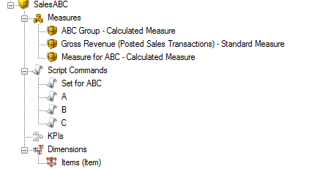

The result:
