Measure in Reporting Currency:
This function will calculate a given measure to a reporting currency. The function is being used in a cube with at least two facttables, one being the exchange rates (one rate per currency per day) and the other being the transactions in the master currency for each company.
Pre-requisites:
A dimension that contains the reporting currencies
- The dimension must have 1 level, containing the Reporting Currency Code and a Name
A dimension that contains the default currency for the individual companies
A time dimension with atleast one hierarchy
- The key level of the dimension must be a Date and the key level must be the part of the hierarchy.
A measure to base the calculation on
- The measure must be in the individual companies default currency.
A measure that contains the exchangerate
- The measure is often hidden since it is just being used in this calculation and does not make any sense on a aggregated level.

The guide below is describing how to use the business function in a Dynamics AX Project – you can see the implementation in the QuickCube for AX:
- Select the following tables from Axapta:
COMPANYINFO
CURRENCY
EXCHRATES
- Since Axapta sets a ToDate to 1900-01-01 for all rates in use we need to update the ToDate to 9999-12-31. To do this create the below Script Action and add it as a Post Script to data cleansing to the EXCHRATES table
UPDATE dbo.AX_dbo_EXCHRATES_V
SET ToDate = IsNull(
(select TOP 1 fromdate as todate from dbo.AX_dbo_EXCHRATES_R WHERE fromdate > b.fromdate AND currencycode = b.currencycode AND dataareaid = b.DataAreaId) ,'9999-12-31'
)
FROM dbo.AX_dbo_EXCHRATES_V b
- On the DWH create a table called ‘ExchangeRates’ containing the following fields:
DataAreaId (datatype as in AX)
FromCurrency – Lookupfield CurrencyCode from table COMPANYINFO (dataareaid = dataareaid)
ToCurrency (VARCHAR(3))
Date (DATETIME)
Rate (Numeric 4)
- Create a Script Action as below and add it as a Pre Script to data cleansing on the ExchangeRates table. Make sure you have a Time table called Time or modify the script accordingly. Also make sure the time table is above the ExchangeRates table in the tree
INSERT INTO [dbo].[ExchangeRates_R]
(
[DataAreaId]
,[FromCurrency]
,[ToCurrency]
,[Date]
,[Rate]
,[DW_SourceCode]
)
select
[DataAreaId]
,'MST'
,b.currencycode
,a.datevalue
,b.exchrate
,'FillScript'
from dbo.Time_V a left join dbo.ExchRates_V b
on a.datevalue > b.Fromdate and a.datevalue <= b.todate where b.currencycode is not null
- Create a table called ReportingCurrencies containing the following fields:
CurrencyCode (VARCHAR(3))
Name – Lookupfield TXT from Table Currency (CurrencyCode = CurrencyCode)
- Add Custom Data to the ReportingCurrencies table for the currencies you want to use for reporting. Make sure you are using the exact same currency code as those in the ExchangeRates table from the data source.
- Create the following dimensions on the OLAP side:
Reporting Currency:
Key: ReportingCurrencies.CurrencyCode
Name: ReportingCurrencies.Name
Transaction Currency:
Key: Currency.CurrencyCode
Name: Currency.TXT
- Create a cube for transactions containing your transactions and the table ExchangeRates as fact-tables
- Setup dimension relations
Transactions fact-table:
Company.DataAreaID
Time.Date
Transaction Currency.CurrencyCode
ExchangeRates fact-table:
Company.DataAreatID
Reporting Currencies.ToCurrency
Time.Date
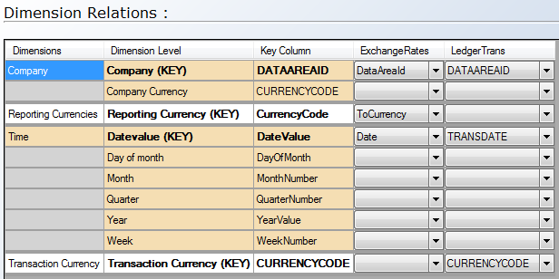
- Create a hidden standard measure ‘ExchangeRate’ as ExchangeRates.Rate
- Create a standard measure ‘AmountMST’ as Transaction-fact-table.AmountMST
- Add the business Function Measure: “Measure in Reporting Currency” and set the parameters accordingly.
You should now be able make currency conversions on the fly. To do this you must make a single selection on one Reporting Currency in you report or display your reporting currencies as rows or columns.

